**PROJECT SUBMISSION**

“Healthy Food Ordering Web App”

*Submitted in partial fulfillment of the requirements for the award of degree of*

**Bachelor of Technology**

**In**

**Computer Science and Engineering**

**(Internet of Things and Cyber Security)**

**Semester – 6th**



**Submitted to:- Submitted by:-**

**Er. Sahil Sharma (Asst. Prof.) Abhijeet Dutta (2121977)**

**Dr. Kanishk Bansal (Asst. Prof.) Semester - 6th**



**IK GUJRAL PUNJAB TECHNICAL UNIVERSITY,**

**JALANDHAR**

**Acknowledgements**

I extend my heartfelt gratitude to all those who played a pivotal role in the development and success of the Healthy Food Ordering Web App project. Your collective efforts and support have been instrumental in bringing this vision to fruition.

First and foremost, I am deeply thankful to Er. Sahil Sharma, my esteemed mentor, and project lead. His expertise, unwavering support, and encouragement were indispensable in shaping every facet of this project. His invaluable insights and guidance not only enriched my understanding of HTML, CSS, and jQuery but also empowered me to navigate through the intricacies of the project with confidence, ultimately leading to the creation of a robust and impactful solution.

I am indebted to the tech community for providing the essential infrastructure, resources, and nurturing environment conducive to the successful execution of this project. Their steadfast support and commitment to fostering innovation have played a pivotal role in propelling the project forward and ensuring its continued progress.

A heartfelt appreciation goes out to TuteDude and ByteWave, my esteemed collaborators, whose contributions in the UI design and logo creation have been invaluable. Their meticulous attention to detail and collaborative spirit were instrumental in ensuring the accuracy and reliability of the web app, underscoring the importance of teamwork in achieving our goals.

I also extend my gratitude to the developers and contributors of open-source libraries such as jQuery. Their remarkable work and dedication in creating powerful tools and frameworks have greatly facilitated the implementation of the web app, underscoring the collaborative nature of the tech community.

Lastly, I extend my appreciation to all those who have inspired and influenced me along this transformative journey, directly or indirectly, contributing to my personal and professional growth. Your insights, encouragement, and shared experiences have enriched my perspective and shaped my path forward, for which I am truly grateful.

In closing, I express my heartfelt gratitude to each and every one of you for your invaluable contributions, support, and belief in the vision of this project. Together, we have achieved something truly remarkable, and I am deeply honored to have been a part of this extraordinary journey.

Thank you all for your unwavering dedication and support.

**PREFACE**

The Healthy Food Ordering Web App project represents a significant step towards promoting healthier eating habits in our modern society. With the increasing pace of life, it has become challenging for many individuals to prioritize their health and nutrition. This project aims to address this issue by providing a convenient and user-friendly platform for ordering nutritious meals.

The inspiration for this project came from a personal desire to make it easier for people to access healthy food options. As someone who is passionate about health and wellness, I understand the importance of making nutritious choices, even in the midst of a busy schedule. This project allowed me to combine my love for technology with my commitment to promoting a healthier lifestyle.

I am grateful for the support and guidance of my mentors and colleagues who have helped shape this project. Their expertise and insights have been invaluable, and I am thankful for the opportunity to collaborate with such talented individuals.

I would also like to express my appreciation to the open-source community for their contributions to the tools and libraries that made this project possible. Their dedication to creating accessible and innovative software has been a source of inspiration.

I hope that this Healthy Food Ordering Web App will empower individuals to make healthier choices and lead happier, more fulfilling lives. Thank you for joining me on this journey towards a healthier future.

**ABSTRACT**

The Healthy Food Ordering Web App is a project aimed at revolutionizing the way people access and order nutritious meals. In today's fast-paced world, maintaining a healthy diet can be challenging, often due to limited time and accessibility to healthy food options. This web app seeks to address these challenges by providing a convenient platform for users to browse, select, and order healthy meals from a variety of restaurants and vendors.

The app features a user-friendly interface that allows users to easily navigate through the menu, customize their orders, and place them with just a few clicks. It also provides detailed information about each dish, including ingredients, nutritional content, and calorie count, enabling users to make informed decisions about their food choices.

One of the key features of the app is its focus on promoting healthy eating habits. It offers a wide range of healthy meal options, including vegetarian, vegan, gluten-free, and low-calorie dishes, catering to a diverse range of dietary preferences and restrictions. Additionally, the app provides users with access to nutritional information and tips, helping them make healthier choices.

Overall, the Healthy Food Ordering Web App aims to make healthy eating more accessible and convenient for everyone. By providing a platform that prioritizes health and nutrition, this app seeks to empower users to take control of their diet and lead healthier lives.

INTRODUCTION

1.1.Objec*ve of the System

1.2.Jus*ﬁca*on and need for the system

1.3.Advantage of the system

1.4 Previous work or related systems, how they

are used.

2 REQUIREMENT ANALYSIS

2.1 Analysis Study

2.2 User Requirements

2.3 Final Requirements

3 DESIGN OF THE SYSTEM

3.1 Hardware, SoJware requirements

3.2 System requirements

3.3 Design Requirement

3.4 DFDs

4 IMPLEMENTATION & CODING

4.1 Opera*ng System

4.2. Languages

4.3 Coding

5 TESTING & TEST RESULTS

1. SoJware Tes*ng and Objec*ve of Tes*ng

5.2 Sample test data/ Output screen printouts

etc.

6 CONCLUSION

1. Conclusion

2. Future Sco

INTRODUCTION

1.1.Objec*ve of the System

1.2.Jus*ﬁca*on and need for the system

1.3.Advantage of the system

1.4 Previous work or related systems, how they

are used.

2 REQUIREMENT ANALYSIS

2.1 Analysis Study

2.2 User Requirements

2.3 Final Requirements

3 DESIGN OF THE SYSTEM

3.1 Hardware, SoJware requirements

3.2 System requirements

3.3 Design Requirement

3.4 DFDs

4 IMPLEMENTATION & CODING

4.1 Opera*ng System

4.2. Languages

4.3 Coding

5 TESTING & TEST RESULTS

1. SoJware Tes*ng and Objec*ve of Tes*ng

5.2 Sample test data/ Output screen printouts

etc.

6 CONCLUSION

1. Conclusion

2. Future Scope

Biblography

INTRODUCTION

1.1.Objec*ve of the System

1.2.Jus*ﬁca*on and need for the system

1.3.Advantage of the system

1.4 Previous work or related systems, how they

are used.

2 REQUIREMENT ANALYSIS

2.1 Analysis Study

2.2 User Requirements

2.3 Final Requirements

3 DESIGN OF THE SYSTEM

3.1 Hardware, SoJware requirements

3.2 System requirements

3.3 Design Requirement

3.4 DFDs

4 IMPLEMENTATION & CODING

4.1 Opera*ng System

4.2. Languages

4.3 Coding

5 TESTING & TEST RESULTS

1. SoJware Tes*ng and Objec*ve of Tes*ng

5.2 Sample test data/ Output screen printouts

etc.

6 CONCLUSION

1. Conclusion

2. Future Scope

Biblography

INTRODUCTION

1.1.Objec*ve of the System

1.2.Jus*ﬁca*on and need for the system

1.3.Advantage of the system

1.4 Previous work or related systems, how they

are used.

2 REQUIREMENT ANALYSIS

2.1 Analysis Study

2.2 User Requirements

2.3 Final Requirements

3 DESIGN OF THE SYSTEM

3.1 Hardware, SoJware requirements

3.2 System requirements

3.3 Design Requirement

3.4 DFDs

4 IMPLEMENTATION & CODING

4.1 Opera*ng System

4.2. Languages

4.3 Coding

5 TESTING & TEST RESULTS

1. SoJware Tes*ng and Objec*ve of Tes*ng

5.2 Sample test data/ Output screen printouts

etc.

6 CONCLUSION

1. Conclusion

2. Future Scope

Biblography

INTRODUCTION

1.1.Objec*ve of the System

1.2.Jus*ﬁca*on and need for the system

1.3.Advantage of the system

1.4 Previous work or related systems, how they

are used.

2 REQUIREMENT ANALYSIS

2.1 Analysis Study

2.2 User Requirements

2.3 Final Requirements

3 DESIGN OF THE SYSTEM

3.1 Hardware, SoJware requirements

3.2 System requirements

3.3 Design Requirement

3.4 DFDs

4 IMPLEMENTATION & CODING

4.1 Opera*ng System

4.2. Languages

4.3 Coding

5 TESTING & TEST RESULTS

1. SoJware Tes*ng and Objec*ve of Tes*ng

5.2 Sample test data/ Output screen printouts

etc.

6 CONCLUSION

1. Conclusion

2. Future Scope

Biblography

INTRODUCTION

1.1.Objec*ve of the System

1.2.Jus*ﬁca*on and need for the system

1.3.Advantage of the system

1.4 Previous work or related systems, how they

are used.

2 REQUIREMENT ANALYSIS

2.1 Analysis Study

2.2 User Requirements

2.3 Final Requirements

3 DESIGN OF THE SYSTEM

3.1 Hardware, SoJware requirements

3.2 System requirements

3.3 Design Requirement

3.4 DFDs

4 IMPLEMENTATION & CODING

4.1 Opera*ng System

4.2. Languages

4.3 Coding

5 TESTING & TEST RESULTS

1. SoJware Tes*ng and Objec*ve of Tes*ng

5.2 Sample test data/ Output screen printouts

etc.

6 CONCLUSION

1. Conclusion

2. Future Scope

Biblography

INTRODUCTION

1.1.Objec*ve of the System

1.2.Jus*ﬁca*on and need for the system

1.3.Advantage of the system

1.4 Previous work or related systems, how they

are used.

2 REQUIREMENT ANALYSIS

2.1 Analysis Study

2.2 User Requirements

2.3 Final Requirements

3 DESIGN OF THE SYSTEM

3.1 Hardware, SoJware requirements

3.2 System requirements

3.3 Design Requirement

3.4 DFDs

4 IMPLEMENTATION & CODING

4.1 Opera*ng System

4.2. Languages

4.3 Coding

5 TESTING & TEST RESULTS

1. SoJware Tes*ng and Objec*ve of Tes*ng

5.2 Sample test data/ Output screen printouts

etc.

6 CONCLUSION

1. Conclusion

2. Future Scope

INTRODUCTION

1.1.Objec*ve of the System

1.2.Jus*ﬁca*on and need for the system

1.3.Advantage of the system

1.4 Previous work or related systems, how they

are used.

2 REQUIREMENT ANALYSIS

2.1 Analysis Study

2.2 User Requirements

2.3 Final Requirements

3 DESIGN OF THE SYSTEM

3.1 Hardware, SoJware requirements

3.2 System requirements

3.3 Design Requirement

3.4 DFDs

4 IMPLEMENTATION & CODING

4.1 Opera*ng System

4.2. Languages

4.3 Coding

5 TESTING & TEST RESULTS

1. SoJware Tes*ng and Objec*ve of Tes*ng

5.2 Sample test data/ Output screen printouts

etc.

6 CONCLUSION

1. Conclusion

2. Future Sc

**TABLE OF CONTENTS**

|  |  |  |
| --- | --- | --- |
| **Chapter No.** | **TOPIC** | **Page No.** |
| **1** | **INTRODUCTION** | **1-2** |
| **2** | **REQUIREMENT ANALYSIS** | **3-4** |
| **3** | **DESIGN OF THE SYSTEM** | **5-7** |
| **4** | **IMPLEMENTATION & CODING** | **8-45** |
| **5** | **TESTING & TEST RESULTS** | **46-48** |
| **6** | **CONCLUSION** | **49** |
| **7** | **REFERENCES** | **50** |

**Chapter-1**

**Introduction**

Welcome to our innovative Healthy Food Ordering Web App, a revolutionary platform designed to simplify and enhance the way you order nutritious meals online. In today's fast-paced world, maintaining a healthy diet is essential for overall well-being. However, finding and ordering healthy food options can often be challenging, especially when faced with limited choices and busy schedules. Our web app aims to address these challenges by providing a comprehensive solution that offers a diverse range of healthy food options from local restaurants and vendors.

Our app is built on the principle that eating well should be convenient and enjoyable. With a user-friendly interface and intuitive design, our platform allows users to easily browse menus, place orders, and track deliveries, all from the comfort of their homes or offices. Whether you're looking for a quick and nutritious lunch or a wholesome dinner for the family, our app has something for everyone.

We understand that health is a top priority for many people, which is why we have partnered with local establishments that prioritize quality and nutrition. Our partners are committed to using fresh, locally sourced ingredients to create delicious and healthy meals that cater to a variety of dietary preferences and requirements. From vegan and gluten-free options to low-carb and high-protein dishes, our app offers a diverse selection to suit every taste and lifestyle.

At the heart of our Healthy Food Ordering Web App is a commitment to making healthy eating more accessible and convenient for everyone. We believe that by providing easy access to nutritious meals, we can help our users improve their overall health and well-being. Join us on this journey to a healthier lifestyle, and experience the convenience and benefits of our innovative web app.

* **OBJECTIVE OF THE SYSTEM**
* This project aims to achieve the following objectives :-

1. Provide users with a seamless and user-friendly interface for effortless browsing and ordering of healthy meals.
2. Offer a wide selection of nutritious food options from local restaurants and vendors to promote healthy eating habits.
3. Ensure convenience and accessibility by allowing users to place orders and track deliveries online.
4. Collaborate with local establishments that prioritize quality and nutrition to ensure that users have access to fresh, wholesome meals.
5. Cater to diverse dietary preferences and requirements, including vegan, gluten-free, low-carb, and high-protein options, to accommodate various lifestyles.
6. Promote health and well-being by making nutritious food choices more accessible and convenient for users.
7. Enhance the overall user experience by providing a platform that not only facilitates healthy eating but also educates and inspires users to make better food choices.

## **KEY FEATURES:**

1. **Extensive Food Selection:** Our Healthy Food Ordering Web App provides a wide range of healthy meal options, including vegan, gluten-free, low-carb, and high-protein choices, catering to diverse dietary needs and preferences.
2. **Easy Ordering Process:** With a user-friendly interface, ordering healthy meals has never been easier. Simply browse through the menus, select your desired items, and place your order with just a few clicks.
3. **Customizable Orders:** Our app allows users to customize their orders to suit their preferences, such as choosing specific ingredients or requesting modifications to dishes, ensuring a personalized dining experience.
4. **Local Vendor Partnerships:** We partner with local restaurants and vendors that prioritize quality and nutrition, ensuring that you receive fresh, wholesome meals made with care and attention to detail.
5. **Delivery Tracking:** Keep track of your order with real-time delivery tracking. Know exactly when your meal will arrive and receive updates throughout the delivery process.
6. **Health and Nutrition Information:** Access detailed information about the nutritional content of each meal, helping you make informed decisions about your food choices.
7. **Promotions and Discounts:** Enjoy exclusive promotions and discounts on healthy meal options, making it more affordable to eat well and maintain a healthy lifestyle.
8. **User Reviews and Ratings:** Read reviews and ratings from other users to help you choose the best healthy meal options and discover new favorites.
9. **Community Engagement:** Join a community of health-conscious individuals who share tips, recipes, and advice on maintaining a healthy lifestyle.
10. **Accessibility:** Our app is accessible via web browsers on desktops, laptops, and mobile devices, ensuring that you can order healthy meals anytime, anywhere.

**Chapter - 2**

**REQUIREMENT ANALYSIS**

* **Functional requirements**

Functional requirements are the specifications that define the functions of the system elements. These requirements can include both functional user requirements and functional system requirements. For the Healthy Food Ordering Web App, the following functional requirements are identified:

1. **User Registration and Login:** Users should be able to create an account and log in to access the app's features.
2. **Browse Menu:** Users should be able to browse through a variety of healthy food options available from local restaurants and vendors.
3. **Place Orders:** Users should be able to select items from the menu, add them to their cart, and place orders for delivery or pickup.
4. **Customize Orders:** Users should be able to customize their orders, such as choosing specific ingredients or specifying cooking preferences.
5. **View Order History:** Users should be able to view their past orders and reorder items if desired.
6. **Track Delivery:** Users should be able to track the status of their orders in real-time, including estimated delivery time and delivery driver information.
7. **Payment Processing:** Users should be able to securely pay for their orders online using various payment methods.
8. **Provide Feedback:** Users should be able to rate and review the meals and overall experience to help improve the service.
9. **Vendor Management:** Vendors should be able to manage their menus, update availability, and receive and manage orders.
10. **Admin Dashboard:** Administrators should have access to a dashboard to manage users, vendors, menus, orders, and other app-related activities.
11. **Reporting and Analytics:** The app should provide reporting and analytics features to track key metrics such as order volume, popular items, and user demographics.

* **ANALYSIS STUDY**

**Low Installation Requirements:** The Healthy Food Ordering Web App is designed to be lightweight and accessible, requiring minimal system specifications for both the server and client programs. This ensures that the app can run smoothly on any standard system with an internet connection, without the need for high-end hardware.

Security and Reliability: The system is built with a strong focus on security and reliability. Measures are in place to ensure that the website remains secure and does not go offline unexpectedly, providing users with a dependable and uninterrupted service.

Availability: The website is designed to be highly available, ensuring that it remains active on the internet and accessible to users at all times. This ensures that users can browse the website whenever they need to, without any downtime or interruptions.

1. **Feasibility Study**

All projects are feasible if they have unlimited resources and infinite time. But the development of software is plagued by the scarcity of resources and difficult delivery rates. It is necessary and prudent to evaluate the feasibility of a project at the earliest possible time. The three considerations are involved in the feasibility analysis.

1. **Technical Feasibility**

Technical feasibility centres on the existing mobile system (hardware, software....etc) and to what extent it can support the proposed addition if the budget is a serious constraint, then the project is judged not feasible. The technical feasibilities are an important role in our project because here we're using HTML, CSS and JavaScript. It requires Visual Studio Code(software) to develop this application. A easily available software and easy to use.

1. **Economical Feasibility**

This procedure is to determine the benefits and savings that are expected from a candidate system and compare them with cost. If the benefits outweigh the cost then the decision is made to design and implement the system. Otherwise, further justification or alterations in proposed systems have to be made if it is having a chance of being approved. This is an ongoing effort that improves any feasibility costs spent on this project because here we're using open-source environments

1. **Operational Feasibility**

People are inherently resistant to change and mobiles have been known to facilitate change. There is no need of technical background is required to work on the application. All the information needed can be seen with just one click.

**Chapter- 3**

**DESIGN OF THE SYSTEM**

1. **Software Requirements**

|  |  |
| --- | --- |
| **Platform** | **Platform Independent** |
| **The Operating System** | **Windows 7** |
| **Framework** | **None** |
| **Front-End Tools** | **Visual Studio Code, HTML, CSS, jQuery.** |
| **API** | **None** |

1. **Hardware Requirements**

|  |  |
| --- | --- |
| **Processor** | **Intel Core i5, Others** |
| **RAM** | **Minimum 2 GB** |
| **Graphics** | **Integrated Graphics Card** |
| **Hard Disk** | **128 GB** |

1. **System Requirements**

The Software Requirements Specification (SRS) is a crucial document that outlines the detailed system requirements for a software project. It serves as a formal agreement between the client and the developer, ensuring that both parties have a clear understanding of the project's scope and objectives. The SRS also acts as a reference for validating the final product, allowing clients to ensure that the software meets their requirements.Establishing the basis for an agreement between the client and the developer.

**Key Features of SRS:**

1. **Establishing Agreement**: The SRS establishes the basis for an agreement between the client and the developer, ensuring that both parties are aligned in terms of project goals and expectations.
2. **Validation Reference:** It provides a reference for validating the final product, allowing clients to determine if the software meets their requirements and specifications.

**Requirements of an SRS:**

**(a) Specification of External Behavior:** The SRS should specify the external behavior of the software, including its functionality and interactions with users and other systems.

**(b) Specification of Constraints:** It should specify any constraints or limitations that may affect the development or implementation of the software.

**(c) Ease of Change:** The SRS should be designed to be easily changeable, allowing for updates and modifications as the project progresses.

**(d) Reference Tool:** It should serve as a reference tool for developers, testers, and other stakeholders throughout the software development lifecycle.

**(e) Lifecycle Documentation:** The SRS should be maintained and updated throughout the lifecycle of the software, reflecting any changes or updates to the project requirements.

**(f) Capacity to Anticipate Undesired Events:** It should have the capacity to anticipate and address undesired events or scenarios, ensuring that the software is robust and resilient in real-world use cases.

1. **Functional Requirements**

Functional requirements are the requirements that describe the functionalities of the system elements. It may involve functional user requirements or functional system requirements.

For example:

1. **User Registration and Login:** Users should be able to create an account and log in to access the app's features.
2. **Browse Menu:** Users should be able to browse through a variety of healthy food options available from local restaurants and vendors.
3. **Place Orders:** Users should be able to select items from the menu, add them to their cart, and place orders for delivery or pickup.
4. **Customize Orders:** Users should be able to customize their orders, such as choosing specific ingredients or specifying cooking preferences.
5. **View Order History:** Users should be able to view their past orders and reorder items if desired.
6. **Track Delivery:** Users should be able to track the status of their orders in real-time, including estimated delivery time and delivery driver information.
7. **Payment Processing:** Users should be able to securely pay for their orders online using various payment methods.
8. **Provide Feedback:** Users should be able to rate and review the meals and overall experience to help improve the service.
9. **Vendor Management:** Vendors should be able to manage their menus, update availability, and receive and manage orders.
10. **Admin Dashboard:** Administrators should have access to a dashboard to manage users, vendors, menus, orders, and other app-related activities.
11. **Reporting and Analytics:** The app should provide reporting and analytics features to track key metrics such as order volume, popular items, and user demographics.
12. **Design Reqirements**
13. **Responsive Design :** The Healthy Food Ordering Web App should be responsive to different screen sizes and devices, ensuring a consistent and user-friendly experience across desktops, tablets, and mobile phones.
14. **User-friendly Interface :** The interface should be intuitive and easy to navigate, with clear labels and minimal clutter. Users should be able to quickly access the information they need to place orders and track deliveries.
15. **Search Functionality :** The app should include a search feature that allows users to easily find specific healthy food options or restaurants based on their preferences.
16. **Order Customization :** Users should be able to customize their orders, such as specifying dietary preferences, adding special instructions, or selecting portion sizes.
17. **Visual Representation :** Utilize visual elements such as images and icons to enhance the presentation of food items and menu options, making it easier for users to make informed decisions.

**Chapter – 4**

**IMPLEMENTATION AND CODING**

* **Section 0: Header with hero image and navigation (fig 4.1)**

**Title: None**

Goodbye junk food. Hello super healthy meals.

Button 1: I’m hungry (go down to sign up section)

Button 2: Show me more (go down to next section)

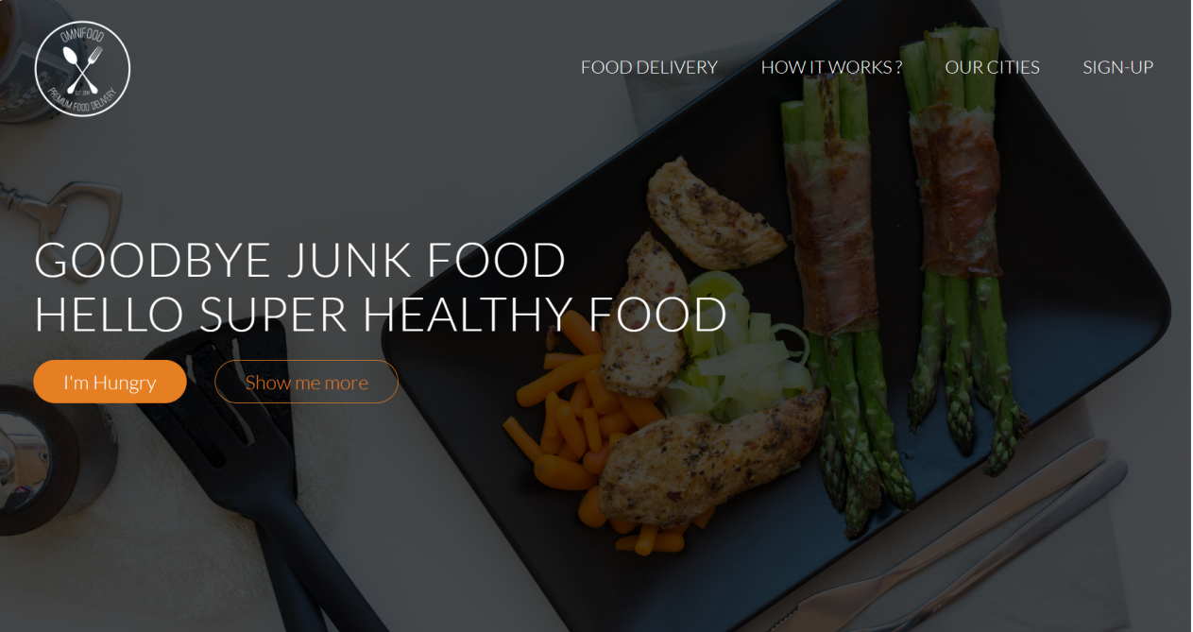

Fig 4. 1

* **Section 1: Features (fig 4.2)**

**Title: Get food fast — not fast food.**

Hello, we’re Omnifood, your new premium food delivery service. We know you’re always busy. No time for cooking. So let us take care of that, we’re really good at it, we promise!

* **Up to 365 days/year**

Never cook again! We really mean that. Our subscription plans include up to 365 days/year coverage. You can also choose to order more flexibly if that's your style.

* **Ready in 20 minutes**

You're only twenty minutes away from your delicious and super healthy meals delivered right to your home. We work with the best chefs in each town to ensure that you're 100% happy.

* **100% organic**

All our vegetables are fresh, organic and local. Animals are raised without added hormones or antibiotics. Good for your health, the environment, and it also tastes better!

* **Order anything**

We don't limit your creativity, which means you can order whatever you feel like. You can also choose from our menu containing over 100 delicious meals. It's up to you!

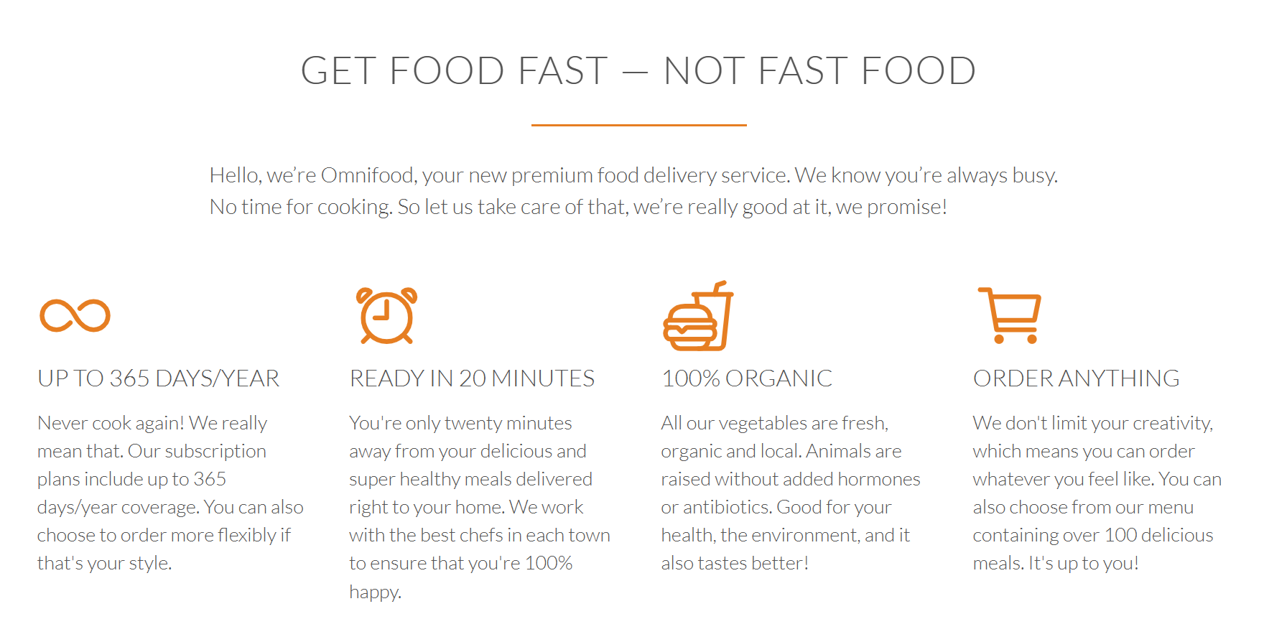

Fig 4. 2

* **Section 2: Favorite meals ( fig 4.3 )**

**Title: None**

1. Korean bibimbap with egg and vegetables
2. Simple italian pizza with cherry tomatoes
3. Chicken breast steak with vegetables
4. Autumn pumpkin soup
5. Motton steak with vegetables
6. Healthy baguette with egg and vegetables
7. Burger with cheddar and chicken
8. Granola with cherries and strawberries

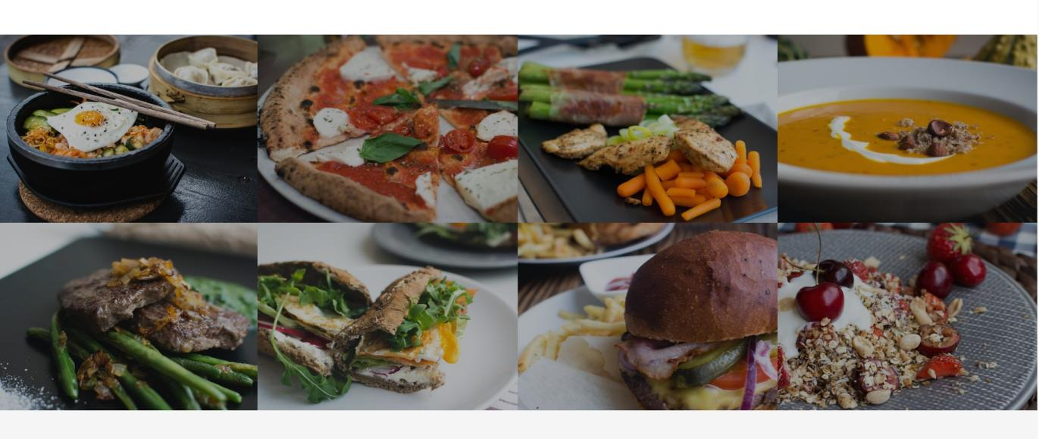

Fig 4. 3

* **Section 3: How it works (fig 4.4)**

**Title:** **How it works - Simple as 1, 2, 3**

1. Choose the subscription plan that best fits your needs and sign up today.
2. Order your delicious meal using our mobile app or website. Or you can even call us!
3. Enjoy your meal after less than 20 minutes. See you the next time!

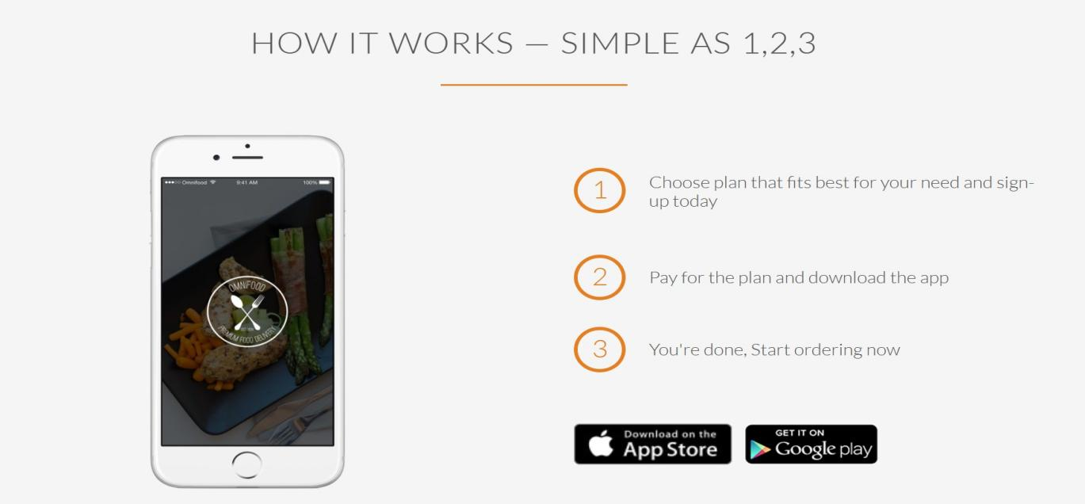

Fig 4. 4

* **Section 4: Cities**

**Title: We're currently in these cities**

**Lisbon**

1600+ happy eaters

50+ top chefs

@omnifood_Lisbon

**San Francisco**

1800+ happy eaters

90+ top chefs

@omnifood_SanFran

**Berlin**

1400+ happy eaters

70+ top chefs

@omnifood_Berlin

**London**

1600+ happy eaters

65+ top chefs

@omnifood_London

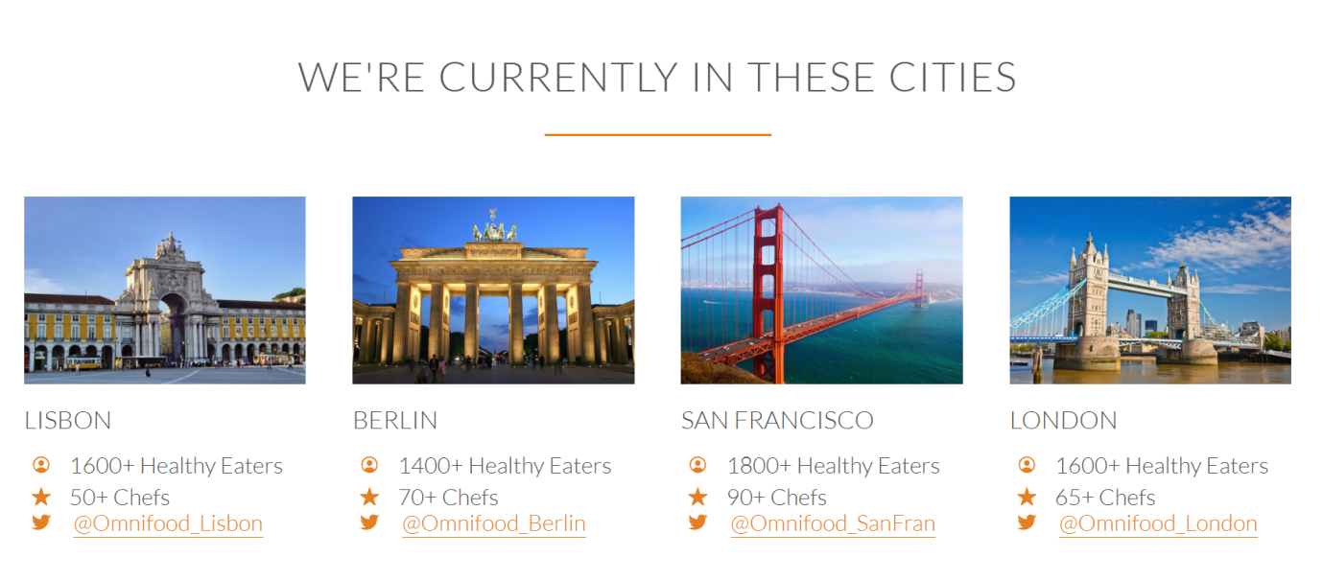

Fig 4. 5

* **Section 5: Customer testimonials (Fig 4.6)**

**Title:** **Our customers can't live without us**

Omnifood is just awesome! I just launched a startup which leaves me with no time for cooking, so Omnifood is a life-saver. Now that I got used to it, I couldn't live without my daily meals!

(Alberto Duncan)

Inexpensive, healthy and great-tasting meals, delivered right to my home. We have lots of food delivery here in Lisbon, but no one comes even close to Omifood. Me and my family are so in love!

(Joana Silva)

I was looking for a quick and easy food delivery service in San Franciso. I tried a lot of them and ended up with Omnifood. Best food delivery service in the Bay Area. Keep up the great work!

(Milton Chapman)

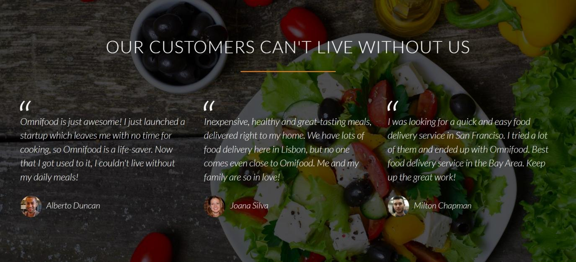

Fig 4. 6

* **Section 6: Sign up and pricing plans**

**Title: Start eating healthy today**

**Plan 1: Premium**

399$ per month

That’s only 13.30$ per meal

1 meal every day

Order 24/7

Access to newest creations

Free delivery

**Plan 2: Pro**

199$ per month

That’s only 13.30$ per meal

1 meal every 2days/month

Order 24/7

Access to newest creations

Free delivery

**Plan 3: Starter**

19$ per meal

1 meal

Order from 8 am to 12 pm

Free delivery

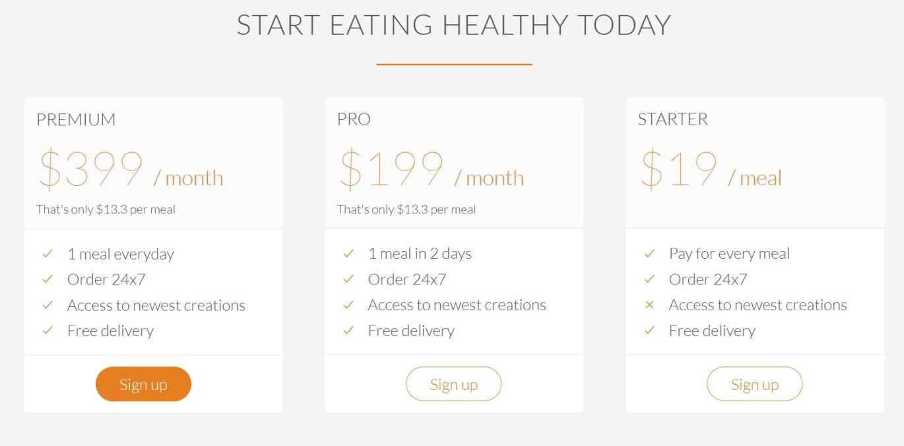

Fig 4. 7

* **Section 7: Contact form**

**Title: We're happy to hear from you**

*Fields to include:*

Name :

Email :

How did you find us? :

Newsletter :

Drop us a line :

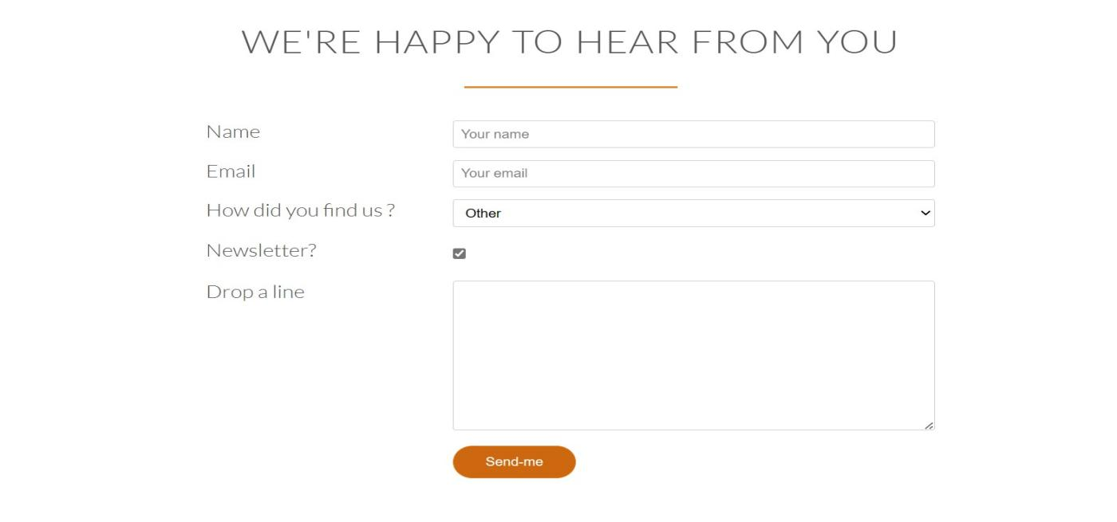

Fig 4. 8

* **Section 8: Footer**

**Title: None**

*Navigation:*

1. About us

2. Blog

3. Press

4. iOS App

5. Android App

Also include links to facebook, twitter, google+ and Instagram accounts.

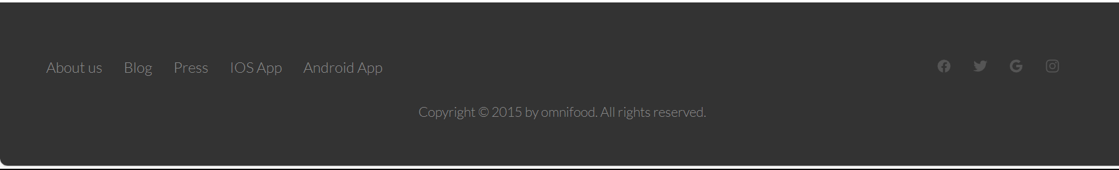

**OPERATING SYSTEM**

Platform Independent: Since the project is done completely in HTML, CSS and jQuery, it also executes the main properties of the language. The application is platform-independent.

**Languages used**

**HTML**

The Hyper Text Markup Language or HTML is the standard markup language for documents designed to be displayed in a web browser. It can be assisted by technologies such as Cascading Style Sheets (CSS) and scripting languages such as JavaScript.

Web browsers receive HTML documents from a web server or from local storage and render the documents into multimedia web pages. HTML describes the structure of a web page semantically and originally included cues for the appearance of the document.

**CSS**

CSS stands for Cascading Style Sheets. It is a style sheet language which is used to describe the look and formatting of a document written in markup language. It provides an additional feature to HTML It is generally used with HTML to change the style of web pages and user interfaces. It can also be used with any kind of XML documents including plain XML, SVG and XUL

CSS is used along with HTML and JavaScript in most websites to create user interfaces for web applications and user interfaces for many mobile applications.

**JavaScript**

JavaScript is a dynamic computer programming language. It is lightweight and most commonly used as a part of web pages, whose implementations allow client-side script to interact with the user and make dynamic pages. It is an interpreted programming language with object-oriented capabilities.

JavaScript was first known as LiveScript, but Netscape changed its name to JavaScript, possibly because of the excitement being generated by Java. JavaScript made its first appearance in Netscape 2.0 in 1995 with the name LiveScript. The general-purpose core of the language has been embedded in Netscape, Internet Explorer, and other web browsers.

**CODING**

**HTML**

<!DOCTYPE html>

<html lang="en">

    <head>

        <title>My Food Project</title>

        <meta charset="UTF-8">

        <meta name="viewport" content="width=device-width, initial-scale=1">

        <link rel="stylesheet" href="vendors\css\normalize.css">

        <link rel="stylesheet" href="vendors\css\grid.css">

        <link rel="stylesheet" href="resources\css\style.css">

        <link rel="stylesheet" href="vendors\css\queries.css">

        <!-- Including Animation on Scrolling(AOS) from GitHub -->

        <link rel="stylesheet" href="https://unpkg.com/aos@next/dist/aos.css" />

        <!--  Including the Font-Family  -->

        <link rel="preconnect" href="https://fonts.googleapis.com">

        <link rel="preconnect" href="https://fonts.gstatic.com" crossorigin>

        <link href="https://fonts.googleapis.com/css2?family=Lato:ital,wght@0,100;0,300;0,400;0,700;0,900;1,100;1,300;1,400;1,700;1,900&display=swap" rel="stylesheet">

    </head>

    <body>

        <header>

            <nav>

                <div class="row">

                    <img class="logo" src="resources/img/logo-white.png" alt="logo-img">

                    <ul class="main-nav">

                        <li><a href="#feature">Food delivery</a></li>

                        <li><a href="#hiw">How it works ?</a></li>

                        <li><a href="#city">Our cities</a></li>

                        <li><a href="#signup">Sign-up</a></li>

                    </ul>

                </div>

            </nav>

            <div class="hero-text-box">

                <h1>Goodbye junk food<br>Hello super healthy food</h1>

                <a class="btn btn-full" href="#plans">I'm Hungry</a>

                <a class="btn btn-ghost" href="#feature">Show me more</a>

            </div>

        </header>

        <section class="section-features" id="feature">

            <div class="row">

                <h2>Get food fast &mdash; Not fast food</h2>

                <p class="long-copy">

                    Hello, we’re Omnifood, your new premium food delivery service. We know you’re

                    always busy. No time for cooking. So let us take care of that, we’re really good at it, we

                    promise!

                </p>

            </div>

            <div class="row">

                <div class="col span-1-of-4 box">

                    <ion-icon class="icon-big" name="infinite-outline"></ion-icon>

                    <h3>Up to 365 days/year</h3>

                    <p>

                        Never cook again! We really mean that. Our subscription plans include up to 365 days/year

                        coverage. You can also choose to order more flexibly if that's your style.

                    </p>

                </div>

                <div class="col span-1-of-4 box">

                    <ion-icon class="icon-big" name="alarm-outline"></ion-icon>

                    <h3>Ready in 20 minutes</h3>

                    <p>

                        You're only twenty minutes away from your delicious and super healthy meals delivered right

                        to your home. We work with the best chefs in each town to ensure that you're 100% happy.

                    </p>

                </div>

                <div class="col span-1-of-4 box">

                    <ion-icon class="icon-big" name="fast-food-outline"></ion-icon>

                    <h3>100% organic</h3>

                    <p>

                        All our vegetables are fresh, organic and local. Animals are raised without added hormones

                        or antibiotics. Good for your health, the environment, and it also tastes better!

                    </p>

                </div>

                <div class="col span-1-of-4 box">

                    <ion-icon class="icon-big" name="cart-outline"></ion-icon>

                    <h3>Order anything</h3>

                    <p>

                        We don't limit your creativity, which means you can order whatever you feel like.

                        You can also choose from our menu containing over 100 delicious meals. It's up to you!

                    </p>

                </div>

            </div>

        </section>

        <section class="section-meals" data-aos="fade-in" data-aos-duration="2000">

            <ul class="meals-showcase clearfix">

                <li>

                    <figure class="meal-photo">

                        <img src="resources\img\1.jpg" alt="food-image">

                    </figure>

                </li>

                <li>

                    <figure class="meal-photo">

                        <img src="resources\img\2.jpg" alt="food-image">

                    </figure>

                </li>

                <li>

                    <figure class="meal-photo">

                        <img src="resources\img\3.jpg" alt="food-image">

                    </figure>

                </li>

                <li>

                    <figure class="meal-photo">

                        <img src="resources\img\4.jpg" alt="food-image">

                    </figure>

                </li>

            </ul>

            <ul class="meals-showcase clearfix">

                <li>

                    <figure class="meal-photo">

                        <img src="resources\img\5.jpg" alt="food-image">

                    </figure>

                </li>

                <li>

                    <figure class="meal-photo">

                        <img src="resources\img\6.jpg" alt="food-image">

                    </figure>

                </li>

                <li>

                    <figure class="meal-photo">

                        <img src="resources\img\7.jpg" alt="food-image">

                    </figure>

                </li>

                <li>

                    <figure class="meal-photo">

                        <img src="resources\img\8.jpg" alt="food-image">

                    </figure>

                </li>

            </ul>

        </section>

        <section class="section-steps" id="hiw" data-aos="fade-in" data-aos-duration="2000">

            <div class="row">

                <h2>How it works &mdash; Simple as 1,2,3</h2>

            </div>

            <div class="row">

                <div class="col span-1-of-2 steps-box">

                    <img src="resources/img/sample-adx.png" alt="phone-image" class="app-screen" data-aos="slide-left" data-aos-duration="1500">

                </div>

                <div class="col span-1-of-2 steps-box">

                    <div class="works-steps">

                        <div>1</div>

                        <p class="step-1">Choose plan that fits best for your need and sign-up today</p>

                    </div>

                    <div class="works-steps">

                        <div>2</div>

                        <p class="simple-steps">Pay for the plan and download the app</p>

                    </div>

                    <div class="works-steps">

                        <div>3</div>

                        <p class="simple-steps">You're done, Start ordering now</p>

                    </div>

                    <a href="#" class="btn-app"><img src="resources/img/iphone.jpg" alt="app-store"></a>

                    <a href="#" class="btn-app"><img src="resources/img/android.png" alt="app-store"></a>

                </div>

            </div>

        </section>

        <section class="section-cities" id="city" data-aos="fade-in" data-aos-duration="2000">

            <div class="row">

                <h2>We're currently in these cities</h2>

            </div>

            <div class="row">

                <div class="col span-1-of-4 box">

                    <img src="resources/img/lisbon.jpg" alt="lisbon">

                    <h3>Lisbon</h3>

                    <div class="city-feature">

                        <ion-icon name="person-circle-outline" class="icon-small"></ion-icon>1600+ Healthy Eaters

                    </div>

                    <div>

                        <ion-icon name="star" class="icon-small"></ion-icon>50+ Chefs

                    </div>

                    <div>

                        <ion-icon name="logo-twitter" class="icon-small"></ion-icon>

                        <a href="#">@Omnifood_Lisbon</a>

                    </div>

                </div>

                <div class="col span-1-of-4 box">

                    <img src="resources/img/berlin.jpg" alt="berlin">

                    <h3>Berlin</h3>

                    <div class="city-feature">

                        <ion-icon name="person-circle-outline" class="icon-small"></ion-icon>1400+ Healthy Eaters

                    </div>

                    <div>

                        <ion-icon name="star" class="icon-small"></ion-icon>70+ Chefs

                    </div>

                    <div>

                        <ion-icon name="logo-twitter" class="icon-small"></ion-icon>

                        <a href="#">@Omnifood_Berlin</a>

                    </div>

                </div>

                <div class="col span-1-of-4 box">

                    <img src="resources/img/san-francisco.jpg" alt="san-francisco">

                    <h3>San Francisco</h3>

                    <div class="city-feature">

                        <ion-icon name="person-circle-outline" class="icon-small"></ion-icon>1800+ Healthy Eaters

                    </div>

                    <div>

                        <ion-icon name="star" class="icon-small"></ion-icon>90+ Chefs

                    </div>

                    <div>

                        <ion-icon name="logo-twitter" class="icon-small"></ion-icon>

                        <a href="#">@Omnifood_SanFran</a>

                    </div>

                </div>

                <div class="col span-1-of-4 box">

                    <img src="resources/img/london.jpg" alt="london">

                    <h3>London</h3>

                    <div class="city-feature">

                        <ion-icon name="person-circle-outline" class="icon-small"></ion-icon>1600+ Healthy Eaters

                    </div>

                    <div>

                        <ion-icon name="star" class="icon-small"></ion-icon>65+ Chefs

                    </div>

                    <div>

                        <ion-icon name="logo-twitter" class="icon-small"></ion-icon>

                        <a href="#">@Omnifood_London</a>

                    </div>

                </div>

            </div>

        </section>

        <section class="section-testimonials" data-aos="fade-in" data-aos-duration="2000">

            <div class="row">

                <h2>Our customers can't live without us</h2>

            </div>

            <div class="row">

                <div class="col span-1-of-3">

                    <blockquote>

                        Omnifood is just awesome! I just launched a startup which leaves me with no time for cooking,

                        so Omnifood is a life-saver. Now that I got used to it, I couldn't live without my daily meals!

                        <cite><img src="resources/img/customer-1.jpg" alt="customer-1">Alberto Duncan</cite>

                    </blockquote>

                </div>

                <div class="col span-1-of-3">

                    <blockquote>

                        Inexpensive, healthy and great-tasting meals, delivered right to my home. We have lots of

                        food delivery here in Lisbon, but no one comes even close to Omifood. Me and my family are so in love!

                        <cite><img src="resources/img/customer-2.jpg" alt="customer-2">Joana Silva</cite>

                    </blockquote>

                </div>

                <div class="col span-1-of-3">

                    <blockquote>

                        I was looking for a quick and easy food delivery service in San Franciso. I tried a lot of them and

                        ended up with Omnifood. Best food delivery service in the Bay Area. Keep up the great work!

                        <cite><img src="resources/img/customer-3.jpg" alt="customer-3">Milton Chapman</cite>

                    </blockquote>

                </div>

            </div>

        </section>

        <section class="section-plans" id="plans" data-aos="fade-in" data-aos-duration="2000">

            <div class="row">

                <h2>Start eating healthy today</h2>

            </div>

            <div class="row">

                <div class="col span-1-of-3">

                    <div class="plan-box">

                        <div>

                            <h3>Premium</h3>

                            <p class="plan-price">$399 <span>/ month</span></p>

                            <p class="plan-price-meal">That's only $13.3 per meal</p>

                        </div>

                        <div>

                            <ul>

                                <li><ion-icon class="icon-small" name="checkmark-outline"></ion-icon>1 meal everyday</li>

                                <li><ion-icon class="icon-small" name="checkmark-outline"></ion-icon>Order 24x7</li>

                                <li><ion-icon class="icon-small" name="checkmark-outline"></ion-icon>Access to newest creations</li>

                                <li><ion-icon class="icon-small" name="checkmark-outline"></ion-icon>Free delivery</li>

                            </ul>

                        </div>

                        <div>

                            <a href="#" class="btn btn-full">Sign up</a>

                        </div>

                    </div>

                </div>

                <div class="col span-1-of-3">

                    <div class="plan-box">

                        <div>

                            <h3>Pro</h3>

                            <p class="plan-price">$199 <span>/ month</span></p>

                            <p class="plan-price-meal">That's only $13.3 per meal</p>

                        </div>

                        <div>

                            <ul>

                                <li><ion-icon class="icon-small" name="checkmark-outline"></ion-icon>1 meal in 2 days</li>

                                <li><ion-icon class="icon-small" name="checkmark-outline"></ion-icon>Order 24x7</li>

                                <li><ion-icon class="icon-small" name="checkmark-outline"></ion-icon>Access to newest creations</li>

                                <li><ion-icon class="icon-small" name="checkmark-outline"></ion-icon>Free delivery</li>

                            </ul>

                        </div>

                        <div>

                            <a href="#" class="btn btn-ghost">Sign up</a>

                        </div>

                    </div>

                </div>

                <div class="col span-1-of-3">

                    <div class="plan-box">

                        <div>

                            <h3>Starter</h3>

                            <p class="plan-price">$19 <span>/ meal</span></p>

                            <p class="plan-price-meal">&nbsp;</p>

                        </div>

                        <div>

                            <ul>

                                <li><ion-icon class="icon-small" name="checkmark-outline"></ion-icon>Pay for every meal</li>

                                <li><ion-icon class="icon-small" name="checkmark-outline"></ion-icon>Order 24x7</li>

                                <li><ion-icon class="icon-small" name="close-outline"></ion-icon>Access to newest creations</li>

                                <li><ion-icon class="icon-small" name="checkmark-outline"></ion-icon>Free delivery</li>

                            </ul>

                        </div>

                        <div>

                            <a href="#" class="btn btn-ghost">Sign up</a>

                        </div>

                    </div>

                </div>

            </div>

        </section>

        <section class="section-form" id="signup" data-aos="fade-in" data-aos-duration="2000">

            <div class="row">

                <h2>We're happy to hear from you</h2>

            </div>

            <div class="row">

                <form action="#" method="POST" class="contact-form">

                    <div class="row">

                        <div class="col span-1-of-3">

                            <label>Name</label>

                        </div>

                        <div class="col span-2-of-3">

                            <input type="text" name="name" id="name" placeholder="Your name" required>

                        </div>

                    </div>

                    <div class="row">

                        <div class="col span-1-of-3">

                            <label for="">Email</label>

                        </div>

                        <div class="col span-2-of-3">

                            <input type="email" name="email" id="email" placeholder="Your email" required>

                        </div>

                    </div>

                    <div class="row">

                        <div class="col span-1-of-3">

                            <label for="">How did you find us ?</label>

                        </div>

                        <div class="col span-2-of-3">

                            <select name="find-us" id="find-us">

                                <option value="friends">Friends</option>

                                <option value="search">Search</option>

                                <option value="ad">Advertisement</option>

                                <option value="other">Other</option>

                            </select>

                        </div>

                    </div>

                    <div class="row">

                        <div class="col span-1-of-3">

                            <label>Newsletter?</label>

                        </div>

                        <div class="col span-2-of-3">

                            <input type="checkbox" name="news" id="news" checked>

                        </div>

                    </div>

                    <div class="row">

                        <div class="col span-1-of-3">

                            <label>Drop a line</label>

                        </div>

                        <div class="col span-2-of-3">

                            <textarea name="text" id="ta" rows="10" cols="30"></textarea>

                        </div>

                    </div>

                    <div class="row">

                        <div class="col span-1-of-3">

                            <label>&nbsp;</label>

                        </div>

                        <div class="col span-2-of-3">

                            <input type="submit" name="submit" id="submit" value="Send-me">

                        </div>

                    </div>

                </form>

            </div>

        </section>

        <footer>

            <div class="row">

                <div class="col span-1-of-2">

                    <ul class="footer-nav">

                        <li><a href="#">About us</a></li>

                        <li><a href="#">Blog</a></li>

                        <li><a href="#">Press</a></li>

                        <li><a href="#">IOS App</a></li>

                        <li><a href="#">Android App</a></li>

                    </ul>

                </div>

                <div class="col span-1-of-2">

                    <ul class="social-links">

                        <li><ion-icon class="facebook" name="logo-facebook"></ion-icon></li>

                        <li><ion-icon class="twitter" name="logo-twitter"></ion-icon></li>

                        <li><ion-icon class="google" name="logo-google"></ion-icon></li>

                        <li><ion-icon class="insta" name="logo-instagram"></ion-icon></li>

                    </ul>

                </div>

            </div>

            <div class="row">

                <p>Copyright &copy; 2015 by omnifood. All rights reserved.</p>

            </div>

        </footer>

        <script type="module" src="https://unpkg.com/ionicons@7.1.0/dist/ionicons/ionicons.esm.js"></script>

        <script nomodule src="https://unpkg.com/ionicons@7.1.0/dist/ionicons/ionicons.js"></script>

        <script src="https://ajax.googleapis.com/ajax/libs/jquery/3.3.1/jquery.min.js"></script>

        <script src="https://ajax.googleapis.com/ajax/libs/jquery/3.3.1/jquery.min.js"></script>

        <script>

            $(document).ready(function(){

            // Add smooth scrolling to all links

            $("a").on('click', function(event) {

                // Make sure this.hash has a value before overriding default behavior

                if (this.hash !== "") {

                // Prevent default anchor click behavior

                event.preventDefault();

                // Store hash

                var hash = this.hash;

                // Using jQuery's animate() method to add smooth page scroll

                // The optional number (800) specifies the number of milliseconds it takes to scroll to the specified area

                $('html, body').animate({

                    scrollTop: $(hash).offset().top

                }, 800, function(){

                    // Add hash (#) to URL when done scrolling (default click behavior)

                    window.location.hash = hash;

                });

                } // End if

            });

            });

        </script>

        <script src="https://unpkg.com/aos@next/dist/aos.js"></script>

        <script>

            AOS.init();

        </script>

    </body>

</html>

**CSS**

* {

    margin: 0;

    padding: 0;

    box-sizing: border-box;

}

html,

body {

    background-color: #ffffff;

    color: #555;

    font-family: Lato, sans-serif;

    font-weight: 300;

    font-size: 20px;

    text-rendering: optimizeLegibility;

    overflow-x: hidden;

}

.row {

    max-width: 1140px;

    margin: 0 auto;

}

header {

    background-image: linear-gradient(rgba(0, 0, 0, 0.7), rgba(0, 0, 0, 0.7)), url('img/hero.jpeg');

    background-attachment: fixed;

    height: 100vh;

    background-size: cover;

    background-position: center;

}

h1 {

    margin-top: 0px;

    margin-bottom: 20px;

    color: #ffffff;

    font-size: 240%;

    font-weight: 300;

    text-transform: uppercase;

    letter-spacing: 1px;

    word-spacing: 3px;

}

.hero-text-box {

    position: absolute;

    width: 1140px;

    top: 50%;

    left: 50%;

    transform: translate(-50%, -50%);

}

.btn:link,

.btn:visited,

input[type=submit] {

    display: inline-block;

    padding-top: 10px;

    padding-right: 30px;

    padding-bottom: 10px;

    padding-left: 30px;

    text-decoration: none;

    font-weight: 300;

    border-radius: 200px;

    transition: background-color 0.4s, border 0.4s, color 0.4s;

}

.btn-full:visited,

.btn-full:link,

input[type=submit] {

    background-color: #e67e22;

    color: #ffffff;

    border: 1px solid #e67e22;

    margin-right: 25px;

    border-radius: 200px;

}

.btn-ghost:visited,

.btn-ghost:link {

    border: 1px solid #e67e22;

    color: #e67e22;

    border-radius: 200px;

}

.btn:hover,

.btn:active,

input[type=submit] {

    background-color: #cd6810;

}

.btn-ghost:hover,

.btn-ghost:active {

    background-color: #cd6810;

    border: 1px, solid, #cd6810;

    color: white;

}

.btn-full:hover,

.btn-full:active,

input[type=submit] {

    border: 1px, solid, #cd6810;

}

.logo {

    height: 100px;

    width: auto;

    float: left;

    margin-top: 20px;

}

.main-nav {

    float: right;

    list-style: none;

    margin-top: 55px;

}

.main-nav li {

    display: inline-block;

    margin-left: 40px;

}

.main-nav li a:link,

.main-nav li a:visited {

    color: #ffffff;

    text-decoration: none;

    text-transform: uppercase;

    font-size: 90%;

    border-bottom: 2px solid transparent;

}

.main-nav li a:hover,

.main-nav li a:active {

    border-bottom: 2px solid #e67e22;

    padding: 8px 0px;

    transition: border-bottom 0.5s, color 0.5s;

}

section {

    padding: 80px 0px;

}

h2 {

    font-weight: 300;

    text-transform: uppercase;

    font-size: 180%;

    word-spacing: 2px;

    text-align: center;

    margin-bottom: 30px;

    letter-spacing: 1px;

}

h2:after {

    display: block;

    height: 2px;

    background-color: #e67e22;

    content: " ";

    width: 200px;

    margin: 0 auto;

    margin-top: 30px;

}

.long-copy {

    line-height: 145%;

    width: 70%;

    margin-left: 15%;

    margin-bottom: 30px;

}

.box {

    padding: 1%;

}

h3 {

    font-weight: 300;

    text-transform: uppercase;

    font-size: 110%;

    margin-bottom: 15px;

}

.box p {

    font-size: 90%;

    line-height: 145%;

}

.icon-big {

    font-size: 350%;

    display: block;

    color: #e67e22;

    margin-bottom: 10px;

}

.meals-showcase {

    width: 100%;

}

.meals-showcase li {

    display: block;

    float: left;

    width: 25%;

}

.meal-photo {

    width: 100%;

    margin: 0;

    overflow: hidden;

    background-color: #000;

transition: transform 0.7s, opacity 0.7s;

}

.meal-photo img {

    width: 100%;

    height: auto;

    transform: scale(1.15);

    opacity: 0.7;

}

.clearfix {

    zoom: 1

}

.clearfix::after {

    content: '.';

    clear: both;

    display: block;

    height: 0;

    visibility: hidden;

}

.section-meals {

    padding: 0;

}

.meal-photo img:hover {

    transform: scale(1.03);

    opacity: 1;

}

.works-steps {

    margin-bottom: 50px;

    margin-right: 25px;

}

.steps-box:first-child {

    text-align: center;

    padding-right: 3%;

    margin-top: 30px;

}

.steps-box:last-child {

    padding-left: 3%;

    margin-top: 70px;

}

.app-screen {

    width: 40%;

    /* box-shadow: 10px 10px 5px #aaaaaa; */

}

.works-steps div {

    color: #e67e22;

    border: 4px solid #e67e22;

    display: inline-block;

    border-radius: 50%;

    height: 55px;

    width: 55px;

    text-align: center;

    padding: 5px;

    float: left;

    font-size: 150%;

    margin-right: 25px;

}

.step-1 {

    padding: 5px;

}

.simple-steps {

    padding-top: 15px;

}

.works-steps:last-of-type {

    margin-bottom: 80px;

}

.btn-app img {

    height: 50px;

    width: auto;

    margin-right: 10px;

}

.btn-app:link,

.btn-app:visited {

    border: 0;

}

.section-steps {

    background-color: #f4f4f4ec;

}

.box img {

    width: 100%;

    height: auto;

    margin-bottom: 15px;

}

.city-feature {

    margin-bottom: 5px;

}

.icon-small {

    display: inline-block;

    width: 30px;

    text-align: center;

    color: #e67e22;

    font-size: 120%;

    line-height: 120%;

    vertical-align: middle;

    margin-top: -5px;

    margin-right: 10px;

}

a:link,

a:visited {

    color: #e67e22;

    text-decoration: none;

    border-bottom: 1px solid #e67e22;

    padding-bottom: 1px;

}

a:hover,

a:active {

    color: #555;

    border-bottom: 1px solid transparent;

    transition: border-bottom 0.5s, color 0.5s;

}

.section-testimonials {

    background-image: linear-gradient(rgba(0, 0, 0, 0.7), rgba(0, 0, 0, 0.7)), url(img/back-customers.jpg);

    background-size: cover;

    color: #ffffff;

    background-attachment: fixed;

}

blockquote {

    padding: 2%;

    font-style: italic;

    line-height: 145%;

    margin-top: 40px;

    position: relative;

}

cite {

    font-size: 90%;

    display: block;

    margin-top: 25px;

}

cite img {

    height: 45px;

    border-radius: 50%;

    margin-right: 10px;

    vertical-align: middle;

}

blockquote::before {

    content: '\201C';

    font-size: 500%;

    display: block;

    position: absolute;

    top: 0;

    left: -3px;

}

.section-plans {

    background-color: #f4f4f4;

}

.plan-box {

    background-color: #ffffff;

    border-radius: 5px;

    width: 90%;

    margin-left: 5%;

}

.plan-box div {

    padding: 15px;

    border-bottom: 1px solid #e8e8e8;

}

.plan-price {

    font-size: 300%;

    margin-bottom: 10px;

    font-weight: 100;

    color: #e67e22;

}

.plan-price-meal {

    font-size: 80%

}

.plan-price span {

    font-size: 45%;

    font-weight: 300;

}

.plan-box ul {

    list-style: none;

}

.plan-box ul li {

    padding: 5px 0px;

}

.plan-box div:last-child {

    border: 0;

    text-align: center;

}

.plan-box div:first-child {

    background-color: #fcfcfc;

    border-top-left-radius: 5px;

    border-top-right-radius: 5px;

}

.contact-form {

    width: 60%;

    margin: 0 auto;

}

input[type=text],

input[type=email],

select,

textarea {

    width: 100%;

    padding: 7px;

    border-radius: 3px;

    border: 1px solid #ccc;

}

textarea {

    height: 100%;

}

input[type=checkbox] {

    margin: 10px 5px 10px 0;

}

footer {

    background-color: #333;

    font-size: 80%;

    padding: 50px;

}

.footer-nav {

    list-style: none;

    float: left;

}

.social-links {

    list-style: none;

    float: right;

}

.footer-nav li,

.social-links li {

    display: inline-block;

    margin-right: 20px;

}

.footer-nav li a:link,

.footer-nav li a:visited,

.social-links li a:link,

.social-links li a:visited {

    text-decoration: none;

    border: 0;

    color: #888;

}

.footer-nav li a:hover,

.footer-nav li a:hover {

    color: #ddd;

}

footer p {

    color: #888;

    text-align: center;

    font-size: 90%;

    margin-top: 20px;

}

.facebook:hover {

    color: #3b5da7;

}

.twitter:hover {

    color: #00aced;

}

.google:hover {

    color: #dd4b39;

}

.insta:hover {

    color: #e0448a;

}

.social-links li a:link,

.social-links li a:visited {

    font-size: 200%;

}

**jQuery**

<script>

            $(document).ready(function(){

            // Add smooth scrolling to all links

            $("a").on('click', function(event) {

                // Make sure this.hash has a value before overriding default behavior

                if (this.hash !== "") {

                // Prevent default anchor click behavior

                event.preventDefault();

                // Store hash

                var hash = this.hash;

                // Using jQuery's animate() method to add smooth page scroll

                // The optional number (800) specifies the number of milliseconds it takes to scroll to the specified area

                $('html, body').animate({

                    scrollTop: $(hash).offset().top

                }, 800, function(){

                    // Add hash (#) to URL when done scrolling (default click behavior)

                    window.location.hash = hash;

                });

                } // End if

            });

            });

        </script>

        <script src="https://unpkg.com/aos@next/dist/aos.js"></script>

        <script>

            AOS.init();

        </script>

**Chapter - 5**

**TESTING & TEST RESULTS**

**SOFTWARE TESTING**

Software testing is a crucial aspect of software quality assurance and serves as the final evaluation of specification design and coding. It involves exposing a system to trial input to determine if the software produces the correct output. However, testing alone cannot guarantee that the software meets all user needs; it can only verify if it conforms to specified requirements. Additionally, testing can identify errors within the system but cannot correct them.

The success of software is measured by its quality, timely delivery, and adherence to budget constraints. Testing plays a crucial role in this process by revealing critical mistakes and ensuring that the software meets performance expectations. It can also help identify inconsistencies in the system, ensuring that it operates as intended. Testing should, therefore,

Validate Performance

Detects Errors

Identify Inconsistencies

**Test Objective:**Effective requirement management is crucial for project cost savings. The following reasons highlight its importance:

**Cost of Requirement Errors:** Repairing requirement errors is significantly more expensive than fixing other types of errors, often costing over 10 times more.

**Prevalence of Requirement Errors:** Requirement errors make up more than 40% of all errors in a software project, emphasizing the need for thorough requirement management.

**Impact of Reduction in Errors:** Even a small reduction in requirement errors can lead to substantial savings in rework costs and schedule delays.

**Unit Testing**

Unit testing is a critical component of the software development process, focusing on testing individual modules or components of a system in isolation. This testing is typically performed by the programmer responsible for coding the module, ensuring that it functions correctly and meets the specified requirements.

During unit testing, the analyst tests the programs that make up the system, often referred to as program testing. This approach allows for the detection of errors in coding and logic that are specific to each module, without considering the interaction between modules initially.

Unit testing can be conducted using a bottom-up approach, starting with the smallest and lowest-level modules and progressing one at a time. A short program is used to execute each module, providing the necessary data to simulate its behavior within the larger system. This approach helps identify and rectify errors within individual modules before they can impact the overall system functionality.

**System Testing**

System testing is conducted after the system has been integrated and is considered as a whole. This phase involves testing the entire system against the specified system requirements to ensure that all requirements have been met and that the system functions as intended.

Testing plays a crucial role in ensuring the success of the system. System testing operates under the logical assumption that if all parts of the system are correct, the system will perform its intended functions successfully. Additionally, system testing serves as a user-oriented validation process before the system is implemented.

The primary function of testing is to detect defects in the software. The ultimate goal of testing is to identify and rectify requirement, design, and coding errors in the programs. Various types of testing are employed during the system testing phase to ensure thorough validation and verification of the system's functionality.

**BLACK-BOX TESTING**

Black-box testing is a method of software testing that focuses on the functionality of an application rather than its internal structures. In this approach, the system is tested to ensure that it meets all expectations and requirements. Testers do not need to have knowledge of the internal logic of the module or system being tested.

Test cases for black-box testing are derived from external descriptions of the software, such as specifications, requirements, and designs. These tests can be functional or non-functional, with the test designer selecting both valid and invalid inputs to determine the correct output. Black-box testing can be applied to all levels of software testing, including unit, integration, functional, system, and acceptance testing.

**WHITE-BOX TESTING**

White-box testing is a software testing technique that involves using explicit knowledge of the internal workings of the item being tested to select the test data. Unlike black-box testing, white-box testing relies on specific knowledge of the programming code to examine outputs. This testing method is accurate only if the tester knows what the program is supposed to do and can determine if it diverges from its intended goal.

In white-box testing, the software is viewed as a "glass-box," meaning that the structure and flow of the software under test are visible to the tester. Testing plans are created based on the details of the software implementation, such as programming language, logic, and styles. Test cases are derived from the program structure.

White-box testing is also known as glass-box testing, logic-driven testing, or design-based testing. This approach offers several techniques, as specific knowledge and attention to the structure of the software under test can ease the problem of intractability.

**Chapter-6**

**CONCLUSION**

In conclusion, the development of the Healthy Food Ordering Web App represents a significant step towards providing users with a convenient and healthy eating solution. Through careful planning, implementation, and continuous improvement, the project aims to meet the diverse needs of users by offering a user-friendly platform with a wide range of healthy food options.

The Healthy Food Ordering Web App not only promotes healthy eating habits but also supports local businesses and fosters community health. By partnering with local establishments that prioritize quality and nutrition, the app aims to provide users with fresh, wholesome meals that cater to their dietary preferences and requirements.

Moving forward, we are committed to enhancing the Healthy Food Ordering Web App to exceed user expectations and make a positive impact on individuals and communities. With a focus on user satisfaction, innovation, and continuous improvement, we are confident that the app will become a trusted resource for users looking to maintain a healthy lifestyle.

Future Scope

While the Healthy Food Ordering Web App has been developed with careful consideration, there are areas where further enhancements can be made:

Expansion to Foreign Countries: Currently, the app focuses on local vendors. However, future versions could consider adding support for international vendors to provide users with a more diverse selection of healthy food options.

Complaint Handling: Implementing a complaint handling system would allow users to provide feedback and address any issues they may encounter, further enhancing the user experience and customer satisfaction.

**Chapter-7**

**REFERENCES**

1. <https://www.w3schools.com/html/>
2. <https://www.geeksforgeeks.org/html-tutorial/>
3. <https://www.tutorialspoint.com/css/index.htm>
4. <https://www.codecademy.com/catalog/language/javascript>
5. <https://www.coursera.org/courses?query=javascript>
6. <https://www.youtube.com/watch?v=VlPiVmYuoqw&t=24273s>
7. <https://www.geeksforgeeks.org/css-tutorial/>
8. <https://web.dev/learn/css>
9. <https://www.udemy.com/topic/css/free/>
10. <https://upskill.tutedude.com>